NOTICE OF PUBLIC AUCTION FOR TREASURER’S DEED

To all current occupants, owners, parties of interest, and to all others listed on the mailing list on file at the Treasurer's Office:
You are hereby notified that on November 19th, 2021, the Treasurer of Custer County, Colorado, sold a tax lien on the following property at public sale to CHAD LIVINGSTON (Original “COP HOLDER”), and then on November 18th, 2022, the Treasurer of Custer County, CO, sold that tax lien on the following property at public sale to SAM TRIPLETT (Current “COP HOLDER”):

LEGAL DESCRIPTION: | DEMOCRAT LODE S#292 SEC 30T22S R71W 10.33 AC; UND 2/3 INT IN BEN EATON LODE #1 S#19313 SEC 30 T22S R7 1W 10.25 AC; BEN EATON LODE #2 S#11963 SEC 30 T22S R71W 8.16 AC
PROPERTY ADDRESS: | N/A

A Certificate of Purchase was issued to Sam Triplett for unpaid property taxes for the year 2021-2024. The property was assessed in the name of EVELYN E GARBER (“PROPERTY OWNER”).

On May 4th, 2026, Sam Triplett, the current certificate holder, filed an Application for a Public Auction of a Certificate of Option for Treasurer’s Deed (COO), under C.R.S. 39-11.5-101.
NOTICE: The property will be sold at public auction to the highest bidder at 209 S 6th St., Westcliffe CO 81252 on Wednesday October 28th, 2026, at 10:00am MST. The sale will include the real estate and all interests held by the Lawful Holder, along with applicable fees, costs, and legal charges.
First Publication: | July 30th, 2026
Last Publication: | August 13^{th,} 2026
Published in: | Wet Mountain Tribune

You may track the Public Auction date on the Treasurer’s website: custercounty-co.gov/treasurer
The property may be redeemed at any time before the actual public auction.
Dated: June 4th, 2026

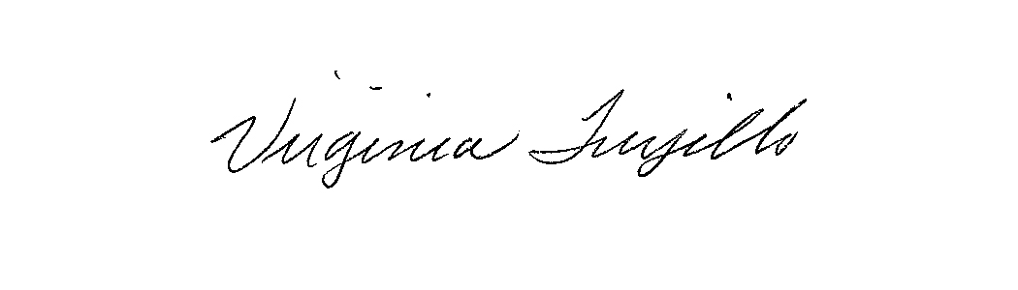
Virginia Trujillo, Treasurer of Custer County, Colorado

