NOTICE OF PUBLIC AUCTION FOR TREASURER’S DEED

To all current occupants, owners, parties of interest, and to all others listed on the mailing list on file at the Treasurer's Office:
You are hereby notified that on November 18th, 2022, the Treasurer of Custer County, Colorado, sold a tax lien on the following property at public sale to SAM TRIPLETT (“COP HOLDER”):
LEGAL DESCRIPTION: | LOT 8 BLK 80 SILVER CLIFF
PROPERTY ADDRESS: | 402 SOUTH ST., SILVER CLIFF CO 81252

A Certificate of Purchase was issued to Sam Triplett for unpaid property taxes for the year 2021-2024. The property was assessed in the name of THE MOON FAMILY TRUST (“PROPERTY OWNER”).

On November 3rd, 2025, Sam Triplett, the current certificate holder, filed an Application for a Public Auction of a Certificate of Option for Treasurer’s Deed (COO), under C.R.S. 39-11.5-101.
NOTICE: The property will be sold at public auction to the highest bidder at 209 S 6th St., Westcliffe CO 81252 on Wednesday May 13th, 2026 at 10:00am MST. The sale will include the real estate and all interests held by the Lawful Holder, along with applicable fees, costs, and legal charges.
First Publication: | January 8th, 2026
Last Publication: | January 22nd, 2026
Published in: | Wet Mountain Tribune

You may track the Public Auction date on the Treasurer’s website: custercounty-co.gov/treasurer
The property may be redeemed at any time before the actual public auction.
Dated: December 17, 2025

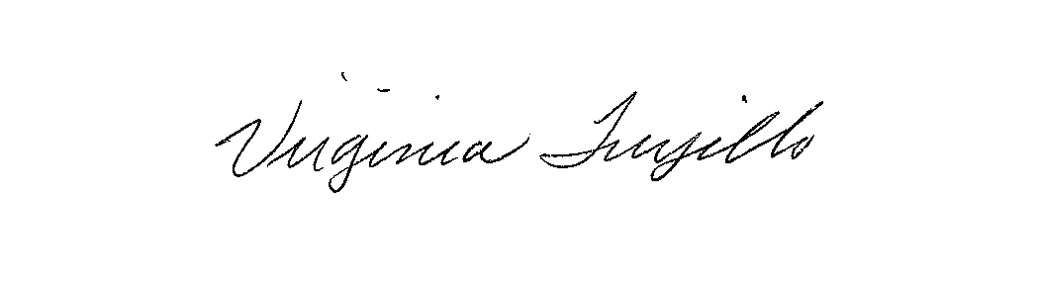
Virginia Trujillo, Treasurer of Custer County, Colorado

